DDL Questions (Data Definition Language)
- Create the TEACHER table with the following attributes: (Name, DeptNo, Date_of_Joining, DeptName, Location, Salary).
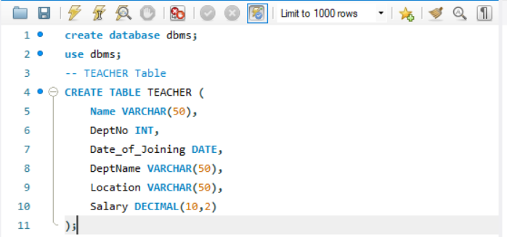
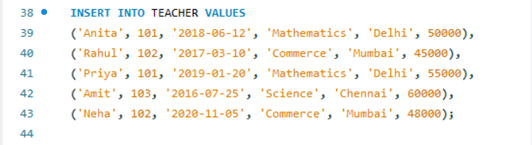

- Create the SALES table with the following attributes: (Sales_No, Salesname, Branch, Salesamount, DOB).
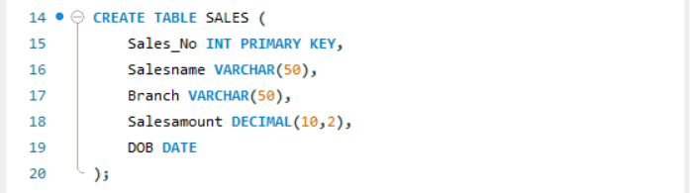
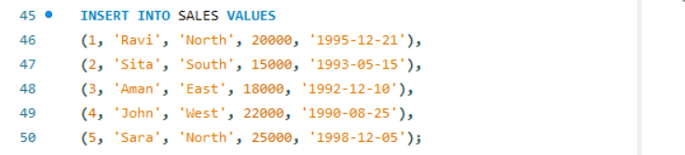

- Create the DEPARTMENTS table with the following attributes: (dept_no, dept_name, dept_location).
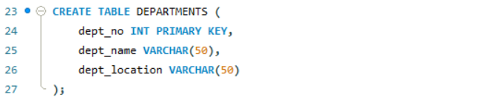
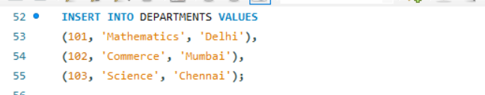

- Create the EMPLOYEES table with the following attributes: (emp_id, emp_name, emp_salary, dept_no).

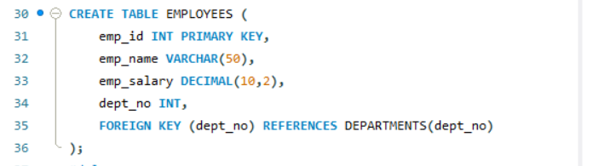
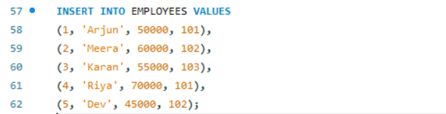

---
DML Questions (Data Manipulation Language)
From TEACHER Table
- Insert five records into the TEACHER table.

- Give an increment of 25% salary to teachers working in the Mathematics department.
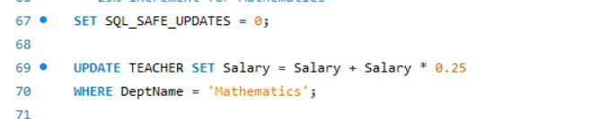

3. Give an increment of 15% salary to teachers working in the Commerce department.


From SALES Table
- Insert five records into the SALES table.

- Calculate the total sales amount in each branch.

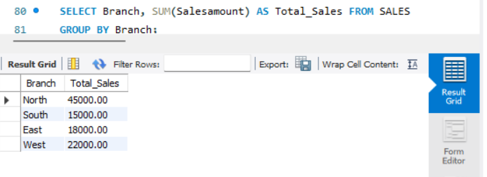
- Calculate the average sales amount in each branch.
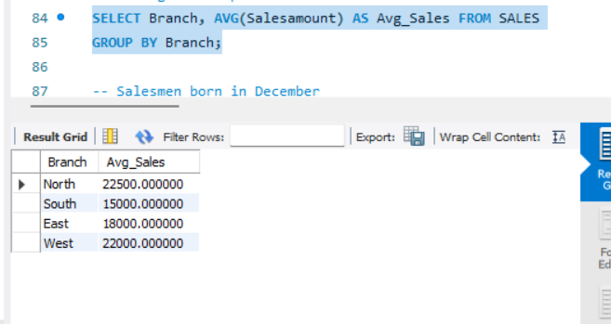

- Display the Salesname and DOB of salesmen born in the month of December with date format like 21-Dec-09.
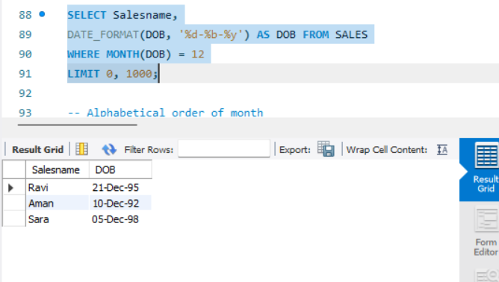

- Display the Salesname and DOB of salesmen in alphabetical order of the month.

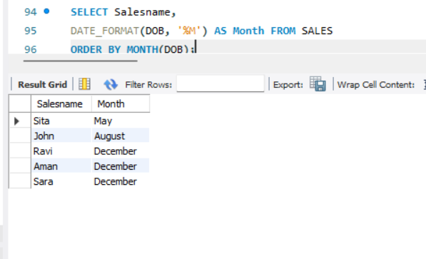

From JOIN Operations
- Display employee details and department details where the department numbers are the same in both tables.
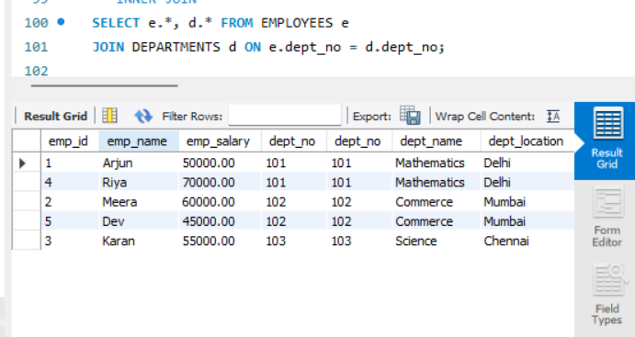

- Display the employee name and department name using a LEFT OUTER JOIN.
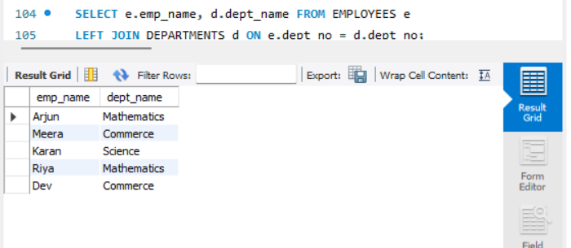

- Display the employee name and department name using a RIGHT OUTER JOIN.
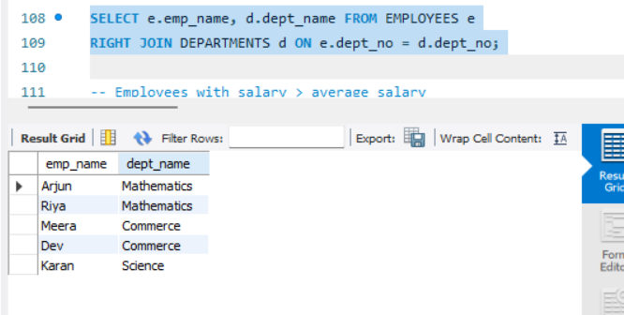

4. Display the details of employees who draw a salary greater than the average salary

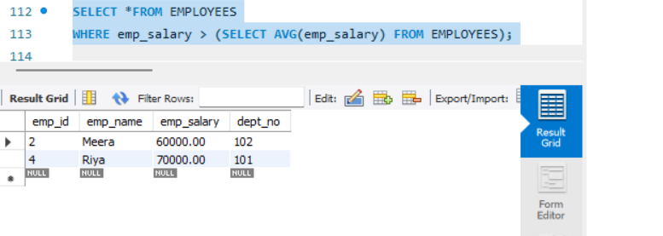

TCL Questions (Transaction Control Language)

- Perform the ROLLBACK command on the TEACHER table.
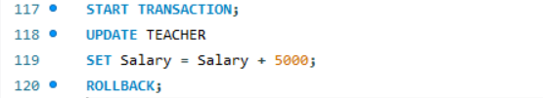
- Perform the COMMIT command on the TEACHER table.
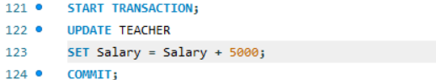

3. Write a query to implement a SAVEPOINT.
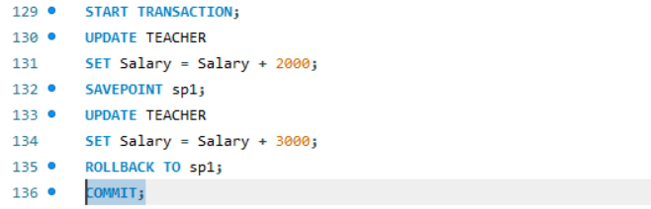

DCL Questions (Data Control Language)

- Write a query to grant all privileges on the EMPLOYEES table to DEPARTMENTS.
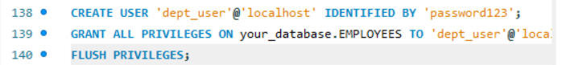
- Write a query to grant selected privileges on the EMPLOYEES table to DEPARTMENTS.

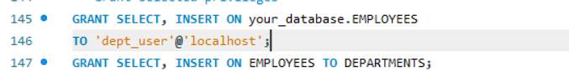

4. Write a query to revoke selected privileges on the EMPLOYEES table from DEPARTMENTS

